|  |  |
| --- | --- |
| **FUNCTIONAL APPROVAL SHEET** | |
| Client Name | PT Astra International Tbk |
| Application Name | Mobile FS – Dashboard CMS |
| Function Name | Dashboard – CMS Mobile FS |
| Menu in Application | Track FS Location |
| Version | 1.0 |

# Main Success Scenario: Track FS Location

1. **Introduction**
2. This is a new submenu in version v.1.0.
3. This page can be accessed by Admin (Area Leader).
4. This page is used to track FS Location and view estimation time & distance of FS to destination.
5. **Navigate to Form**
6. To load this form, Admin must access ‘(link CMS)’, log in to the application. Application will display ‘Track FS Location’ as their default page:

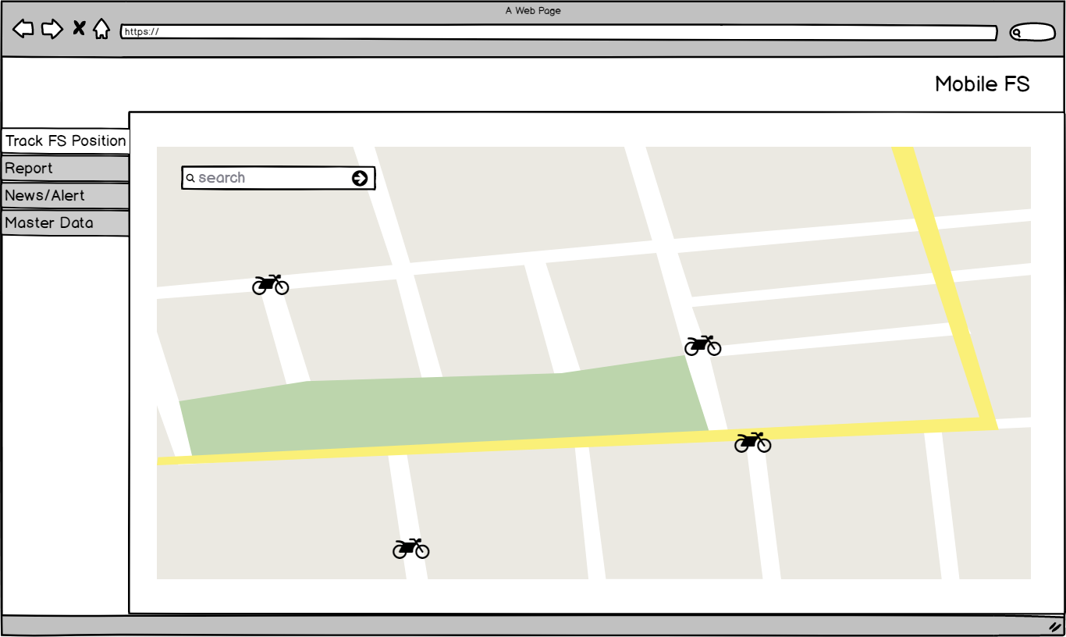

Figure 1 – Navigation to Track FS Location – Mobile FS

**Condition [Figure 1]:**

* When initially loaded, application will enable following attributes:
* ‘Search’ text box.
* Application will display all FS with ‘Active’ status every 15 minutes. If application doesn’t receive location updates in 15 minutes, then FS status will be offline and will not be shown in the map.
* Admin can search FS location by typing ‘Name’/ ‘UserID’ / ‘Email’ on ‘Search’ text box, then clicks ‘🡺’ button.



Figure 2 – ‘Search’ Text Box – Track FS Location

Application will display the search result by showing the FS in the map.

1. **Function Provided in Form**

In this form, User can view data as follow:

1. View Detail FS

To view the detail of existing data, Admin must do following steps:

* 1. Admin search the FS in ‘Search’ text box, then clicks ‘🡺’ button:



Figure 3 – ‘Search’ Text Box – Track FS Location

* 1. Then application will display detail FS in a pop up form as shown below:

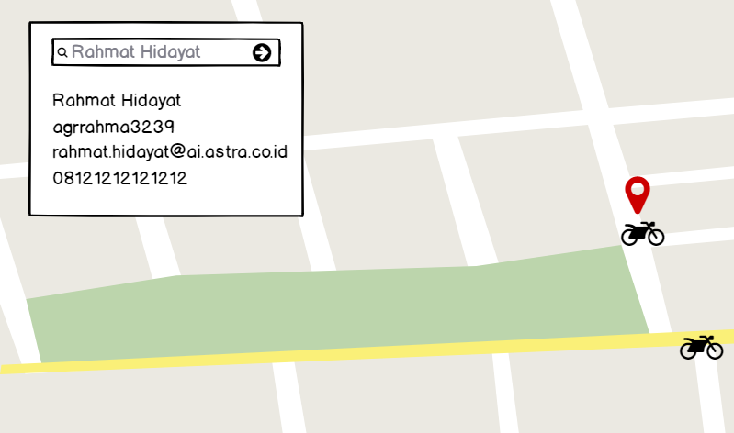

Figure 4 – Display FS Details – Track FS Location

**Condition [Figure 4]:**

* In View FS details, application will display a pop up form with FS information details. Data displayed in FS details are taken from following tables and columns:

|  |  |  |  |
| --- | --- | --- | --- |
| **COLUMN IN DATA GRID** | **TABLE IN DATABASE** | **COLUMN IN DATABASE** | **DESCRIPTION** |
| Name |  |  | Name of the FS. |
| UserID |  |  | UserID of the FS. |
| Email |  |  | Email of the FS. |
| Phone |  |  | Phone number of the FS. |
| Basecamp |  |  | Default branch location of the FS. |

* 1. Admin can clear the ‘Search’ text field, then clicks ‘🡺’ button to go back to the map.

1. View Estimation Time & Distance of FS to Destination.

To view estimation time & distance of FS to destination, Admin must do following steps:

* 1. Admin selects one of the FS icons in map.

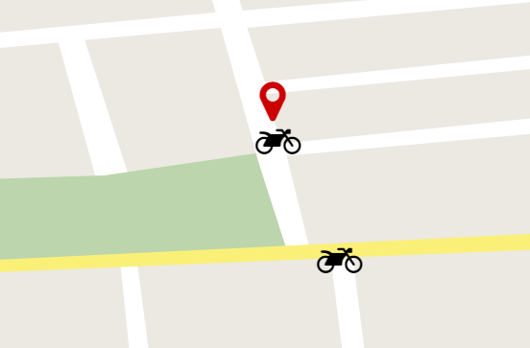

Figure 5 – Selects FS – Track FS Location

* 1. Admin inputs the destination in destination **(To)** text box, then clicks ‘🡺’ button as shown below:

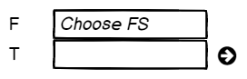

Figure 6 – ‘Destination’ Text Field – Track FS Location

* 1. Application will display the estimation time and distance of FS to destination as shown below:

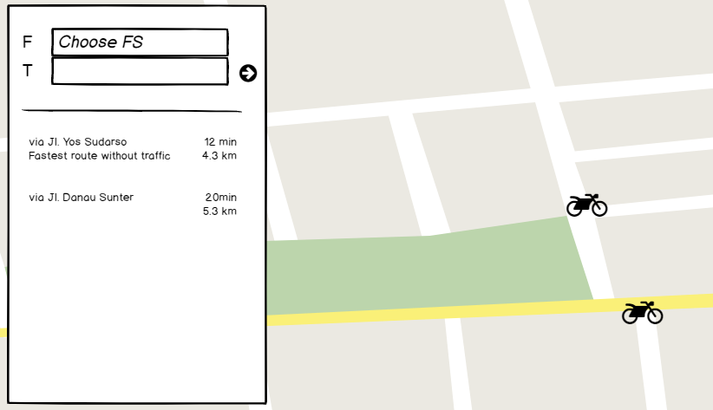

Figure 7 – Display FS Estimation Time & Distance – Track FS Location

# Extension

When ‘Search’ button clicked in search FS estimation time and distance function:

1. If ‘Search’ text field is empty, following message will be shown:

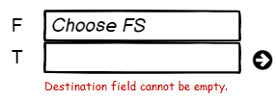

Figure 8 – Error Message – Track FS Location

|  |  |  |  |
| --- | --- | --- | --- |
| PREPARED BY | REVIEWED BY | | APPROVED BY |
|  |  |  |  |
| Name: Rizky Fitriandini | Name: Yongkie Saputra | Name: Rahmat Hidayat | Name: Arif |
| Moonlay Business Analyst | Moonlay Project Manager | Product Manager | Project Owner |
| Date: March 20th, 2018 | Date: April 10th, 2018 | Date: | Date: |

Copyright © Moonlay Technologies. All Rights Reserved.